**TAX CONNECT**

303rd Issue: 20thJune 2021 – 26thJune 2021

12017

**Knowledge Partner:**



**TAX CONNECT**

**Mumbai  :**A/1001, Cirrus Bldg, Cosmos Paradise; Pokhran Road No. 1, Thane (West), Maharashtra – 400606

**Bangalore**:A-414,Carlton Towers,19th Main; Road Hal Old Airport Rd, Domlur, Bengaluru, Karnataka-560008

**New Delhi :**B-139, 2nd Floor, Transport Nagar, Noida-201301 (U.P)

**Kolkata**  :1, Old Court House Corner, “Tobacco House” 1st Floor, R.No.-13 (North), Kolkata-700001

:Room No 119; 1st Floor; Diamond Arcade; 1/72, Cal Jessore Road; Kolkata – 700055

**Dubai**: Azizi Feirouz, 803, 8th Floor, AL Furjan, Opposite Discovery Pavillion, Dubai, UAE

**Contact: +91 9874466163; +91 9830661254**

**Website:** [**www.taxconnect.co.in**](http://www.taxconnect.co.in)

**Email:** [**info@taxconnect.co.in**](mailto:info@taxconnect.co.in)

**Email:** [**info@taxconnect.co.in**](mailto:info@taxconnect.co.in)



**Friends,**

The whole Covid-19 pandemic situation has made government to release a lot of relaxations and clarifications. India's [tax pie](https://economictimes.indiatimes.com/topic/tax-pie) seems to have undergone a subtle change with a sharp drop in direct tax collections resulting from a disproportionate impact of the COVID-19 carnage on incomes.

**Passing on the benefit of reduced GST rates**

One big relief to common man would be the reduction of GST Rate on Hand sanitizers and thermometers by 13%. The reduction will only apply till 30th September, 2021 which leads to the fact that the government does not wish to create a further burden on the already burdened exchequer due to deplete tax revenues.

**TECHNICAL GLITCHES ON NEW INCOME TAX PORTAL:**

The new I-T e-filing portal [www.incometax.gov.in](http://www.incometax.gov.in) has been experiencing numerous technical glitches since its launch on June 7. The senior officials from ministry of finance would hold an interactive meeting with the Infosys regarding glitches in the new Income Tax portal. Other stakeholders including members from Institute of Chartered Accountants of India (ICAI), auditors, consultants and taxpayers will also be a part of the interaction. Written representations on the problems/difficulties faced in the portal have also been invited from the stakeholders.

**RELAXATION IN FILLING OF 15CA & 15CB**

CBDT grants relaxation in electronic filing of forms 15CA & 15CB in view of difficulties reported by taxpayers in filing of forms online on the new e-filing portal www.incometax.gov.in. The forms can be submitted in manual format to the authorized dealers till 30th June, 2021.

**We urge you all to take good care of yourself and your families during these challenging times.**

**We do hope that this bulletin adds value to your professional sphere.**

**Just to reiterate that we remain available over telecom or e-mail.**

**Truly Yours**

**Editor:**

**Vivek Jalan**

Partner - Tax Connect Advisory Services LLP

**Co-Editors:**

**Rohit Sharma**

Senior Manager – Tax Connect Advisory Services LLP

**Rajanikant Choudhury**

Manager - Tax Connect Advisory Services LLP

**Stay Safe and Healthy**

|  |  |  |
| --- | --- | --- |
| S.NO. | TOPICS | PAGE NO. |
| **1]** | **TAX CALENDER** | **4** |
| **2]** | **INCOME TAX** | **5** |
| **NOTIFICATION** | NOTIFICATION NO. 73/2021 DATED 15TH JUNE 2021- THE COST INFLATION INDEX FOR FY 2021-22 RELEVANT TO AY 2022-23 & SUBSEQUENT YEARS IS 317. |  |
| **CASE LAW** | THE DEPARTMENT CANNOT TAKE A DIFFERENT VIEW BY REOPENING OF ASSESSMENT FROM THE VIEW IS TAKEN FOR THE ANOTHER ASSESSMENT YEAR. |  |
| **3]** | **GST** | **6** |
| **NOTIFICATION** | REDUCED CENTRAL GOODS AND SERVICES TAX (CGST) RATES FOR COVID MEDICINES AND OTHER RELATED MEDICAL ESSENTIALS NOTIFIED |  |
| **4]** | **FEMA** | **7** |
| **CASELAW** | THE SEARCH AND SEIZURE OPERATION HAS BEEN CARRIED OUT AND EXCESS JWELLERY HAS BEEN SEIZED. THE SEARCH AND SEIZURE OPERATION HAS BEEN CHALLENGED THROUGH THE WRIT PETITION IN THE HON’BLE CALCUTTA HIGH COURT. |  |
| **5]** | **CUSTOMS** | **8** |
| **NOTIFICATION** | NOTIFICATION NO. 54/2021-CUSTOMS (N.T.) DATED 17.06.2021 HAS BEEN ISSUED TO NOTIFY THE RATE OF EXCHANGE OF CONVERSION OF FOREIGN CURRENCIES INTO INDIAN CURRENCY OR VICE VERSA: |  |
| **6]** | **DGFT** | **9** |
| **PUBLIC NOTICE** | PUBLIC NOTICE NO. 6/2015-2020 DATED 14TH JUNE 2021 ISSUED TO STATE THAT THE CASHEW EXPORT PROMOTION COUNCIL OF INDIA’S POWERS TO ISSUE/RENEW RCMCS FOR PRODUCTS FALLING UNDER THEIR JURISDICTION ARE SUSPENDED AND AGRICULTURAL AND PROCESSED FOOD PRODUCTS EXPORT DEVELOPMENT AUTHORITY (APEDA) IS DESIGNATED AS THE AGENCY AUTHORIZED TO ISSUE RCMCS FOR CASHEW KERNELS, CASHEWNUT SHELL LIQUID AND KARDANOL. |  |
| **NOTIFICATION** | THE EXPORT OF INJECTION REMDESIVIR AND REMDESIVIR ACTIVE PHARMACEUTICAL INGREDIENTS (API) FALLING UNDER THE ITC (HS) CODES SPECIFIED ABOVE OR FALLING UNDER ANY OTHER HS CODE HAS BEEN PUT UNDER RESTRICTED CATEGORY VIDE NOTIFICATION NO. 08/2015-2020 DATED 14TH JUNE 2021. |  |
| **7]** | **IN STANDS - AN INTEGRATED APPROACH TO GST E-INVOICING, E-WAYBILL & E-RETURN FILING** | **10** |
| **8]** | **IN STANDS –SECTION WISE COMPENDIUM ON GST** | **11** |
| **9]** | **IN STANDS – UNION BUDGET 2021** | **12** |
| **10]** | **LET’S DISCUSS FURTHER** | **13** |

|  |  |  |  |
| --- | --- | --- | --- |
| **Due date** | **Form/Return/Challan** | **Reporting Period** | **Description** |
| **20th June 2021** | [**GSTR - 5**](https://www.taxmanagementindia.com/visitor/detail_forms.asp?ID=1207&kw=Return-for-Non-resident-taxable-person) | **May 2021** | **Return by non-resident taxable person** |
| **20thJune 2021** | [**GSTR - 5A**](https://www.taxmanagementindia.com/visitor/detail_forms.asp?ID=1208&kw=Details-of-supplies-of-online-information-and-database-access-or-retrieval-services-by-a-person-located-outside-India-made-to-non-taxable-persons-in-India) | **May 2021** | **OIDAR Service providers** |
| **20th June 2021** | **GSTR 3B** | **May 2021** | **The due date for GSTR-3B having an Annual Turnover of more than 5 Crores** |
| **25th June 2021** | **GST Challan** | **For all Quarterly filers-** | **GST Challan Payment if no sufficient ITC for April (for all Quarterly Filers)** |

NOTIFICATIONS/CASE LAW

**MINISTRY OF FINANCE (Department Of Revenue)**

**(CENTRAL BOARD OF DIRECT TAXES), NOTIFICATION NO. 73/2021**

**Our Comments:** The Central Board of Direct Taxes (CBDT) on June 15 notified the cost inflation index for the current fiscal (2021-22) vide N. No. 73/2021 dated 15th June 2021. The Cost Inflation Index for FY 2021-22 relevant to AY 2022-23 & subsequent years is 317.

The cost inflation index (CII) is used by taxpayer to compute gains arising out of sale of capital assets (immovable property, securities and jewellery etc.) after adjusting inflation. For last Financial Year 2020-21, this index was 301.

**[For further details please refer the Notification]**

**M/S. CAVINKARE PVT. LTD. vs. THE DEPUTY COMMISSIONER OF INCOME TAX, COMPANY CIRCLE 1 (3), THE ASSISTANT COMMISSIONER OF INCOME TAX, CHENNAI**

**Brief:** The department cannot take a different view by reopening of assessment u/s 147 in the matter of disallowance u/s 36(i)(ii) for director’s remuneration for the assessment year 2007-2008 from the view is taken for the assessment year 2008-2009 by the Commissioner of Income Tax (Appeals).

**Our Comments:** For the assessment year 2008-2009, the assessment was sought to be reopened on similar grounds under a similar notice Section 148 of the Income Tax Act, 1961. The Commissioner of Income Tax (Appeals) vide order dated 15.12.2017 has dropped the proceeding.

Reopening of the completed assessment based on change of opinion has been frowned upon by the Apex Court by its several decisions. The decision cited by the petitioner are squarely applicable facts and circumstances of the case. Even if the matter is remitted back to the respondents to pass a speaking order, no useful purpose would be served as the respondents appear to have accepted the views of the Commissioner of Income Tax (Appeals) vide order dated 15.12.2017 for the assessment years 2008-2009 under similar circumstances.

The respondents have also not produced any documents to show that the said order of the Commissioner of Income Tax (Appeals) has been appealed against before the Income Tax Appellate Tribunal and an Appeal is pending as on dated. Therefore, even on merits it is not permissible to the respondents to proceed with the impugned proceeding contrary to the said order.

As an assessing officer, the respondent cannot take a different view for the assessment year 2007-2008 from the view is taken for the assessment year 2008-2009 by the Commissioner of Income Tax (Appeals) in the light of the decision of the Hon'ble Supreme Court, Union of India Vs Kamalakshi Finance Corporation Limited.

**[In favour of the assessee]**

NOTIFICATION

**MINISTRY OF FINANCE, (Department of Revenue) Notification No. 05/2021-Central Tax (Rate) READ WITH CORRIGENDUM NO. G.S.R. 411(E) dated 15-06-2021**

**Our Comments:** The Ministry of Finance (Department of Revenue) on the recommendations of the GST Council on June 14 has notified reduced Central Goods and Services Tax (CGST) rates for Covid medicines and other related medical essentials as tabulated below:

|  |  |  |  |
| --- | --- | --- | --- |
| **Sl.**  **No.** | **Chapter, Heading, Sub-heading or Tariff item** | **Description of Goods** | **Rate** |
| **(1)** | **(2)** | **(3)** | **(4)** |
| 1 | 2804 | Medical Grade Oxygen | 2.5% |
| 2 | 30 | Tocilizumab | Nil |
| 3 | 30 | Amphotericin B | Nil |
| 4 | 30 | Remdesvir | 2.5% |
| 5 | 30 | Heparin (anti-coagulant) | 2.5% |
| 6 | 3002 or 3822 | Covid-19 testing kits | 2.5% |
| 7 | 3002 or 3822 | Inflammatory Diagnostic (marker) kits, namely- IL6, D- Dimer, CRP (C-Reactive Protein), LDH (Lactate De- Hydrogenase), Ferritin, Pro Calcitonin (PCT) and blood gas reagents. | 2.5% |
| 8 | 3808 94 | Hand Sanitizer | 2.5% |
| 9 | 6506 99 00 | Helmets for use with non-invasive ventilation | 2.5% |
| 10 | 8417 or 8514 | Gas/Electric/other furnaces for crematorium | 2.5% |
| 11 | 9018 19 or 9804 | Pulse Oximeter | 2.5% |
| 12 | 9018 | High flow nasal canula device | 2.5% |
| 13 | 9019 20 or 9804 | Oxygen Concentrator/ generator | 2.5% |
| 14 | 9018 or 9019 | Ventilators | 2.5% |
| 15 | 9019 | BiPAP Machine | 2.5% |
| 16 | 9019 | (i) Non-invasive ventilation nasal or oronasal masks for ICU ventilators  (ii) Canula for use with ventilators | 2.5% |
| 17 | 9025 | Temperature check equipment | 2.5% |
| 18 | 8702 or 8703 | Ambulance | 6% |

CASE LAW

**CALCUTTA HIGH COURT: M/S. BANKA BULLION PRIVATE LIMITED VERSUS ASSISTANT DIRECTOR & ORS.**

**BRIEF:** Search and seizure operation carried out and excess jewellery seized by the officers of the Enforcement Directorate under FEMA. The Search and seizure operation has been challenged through the writ petition in the hon’ble Calcutta High Court.

With regard to the search and seizure of the excess jewellery that has been seized by the Enforcement Directorate, it is to be noted that in the writ petition, the petitioner has relied on several documents to indicate that this “excess jewellery” was duly accounted for and had been sent for job work. In view of the Hon’ble High Court, the Enforcement Directorate should look into the documents filed in the writ petition and pass a reasoned order on whether these goods are stock-in-trade or not.

**Our Comments:** The Enforcement Directorate had look into the documents filed in the writ petition and finds that the same are duly accounted for, the same should be released in favour of the petitioner in accordance with law. The above enquiry and the reasoned order should be passed within a period of eight weeks from date.

The authorities are also directed to allow the authorized representative of the petitioner-company to have a lawyer of his choice to be present during the summons at an inaudible distance as per the guidelines laid down by the Supreme Court.

The petitioner shall cooperate with the authorities. The court further hasten to clarify that The court have not gone into the merits of this case. With these above observations and directions, the writ petition stands disposed of.

NOTIFICATIONS

**EXCHANGE RATE NOTIFICATION OF FOREIGN CURRENCY** **MINISTRY OF FINANCE, (DEPARTMENT OF REVENUE) (CENTRAL BOARD OF INDIRECT TAXES AND CUSTOMS) -Notification No. 54/2021 - Customs (N.T.)**

**OUR COMMENTS:** The Ministry of Finance, Government of India, Central Board of Indirect Taxes and Customs vide Notification No. 54/2021-Customs (N.T.) dated 17.06.2021 has notified the rate of exchange of conversion of foreign currencies into Indian currency or vice versa:

**SCHEDULE-I**

|  |  |  |  |
| --- | --- | --- | --- |
| **Sl. No.** | **Foreign Currency** | **Rate of exchange of one unit of foreign currency equivalent to Indian rupees** | |
| **(1)** | **(2)** | **(3)** | |
|  |  | **(a)** | **(b)** |
|  |  | **(For Imported Goods)** | **(For Exported Goods)** |
| 1. | Australian Dollar | **57.50** | **55.05** |
| 2. | Bahraini Dinar | **202.05** | **189.20** |
| 3. | Canadian Dollar | **61.15** | **58.95** |
| 4. | Chinese Yuan | **11.65** | **11.30** |
| 5. | Danish Kroner | **12.10** | **11.65** |
| 6. | EURO | **90.00** | **86.85** |
| 7. | Hong Kong Dollar | **9.65** | **9.30** |
| 8. | Kuwaiti Dinar | **252.75** | **236.65** |
| 9. | New Zealand Dollar | **53.60** | **51.30** |
| 10. | Norwegian Kroner | **8.85** | **8.55** |
| 11. | Pound Sterling | **104.90** | **101.40** |
| 12. | Qatari Riyal | **20.60** | **19.20** |
| 13. | Saudi Arabian Riyal | **20.30** | **19.05** |
| 14. | Singapore Dollar | **56.10** | **54.20** |
| 15. | South African Rand | **5.45** | **5.10** |
| 16. | Swedish Kroner | **8.90** | **8.55** |
| 17. | Swiss Franc | **82.75** | **79.50** |
| 18. | Turkish Lira | **8.80** | **8.30** |
| 19. | UAE Dirham | **20.70** | **19.45** |
| 20. | US Dollar | **74.55** | **72.85** |

**SCHEDULE-II**

|  |  |  |  |
| --- | --- | --- | --- |
| **Sl. No.** | **Foreign Currency** | **Rate of exchange of 100 units of foreign currency equivalent to Indian rupees** | |
| **(1)** | **(2)** | **(3)** | |
|  |  | **(a)** | **(b)** |
|  |  | **(For Imported Goods)** | **(For Export Goods)** |
| 1. | Japanese Yen | **67.80** | **65.35** |
| 2. | Korean Won | **6.75** | **6.30** |

[For further details please refer the notification]

**PUBLIC NOTICE/NOTIFICATION**

**Amendment in Appendix-2T of Foreign Trade Policy, 2015-2020**

**Our Comments:** The Ministry of commerce & industry, Department of Commerce, Directorate General of Foreign Trade videPublic notice No. 6/2015-2020 dated 14th June 2021 amended the Appendix-2T of Foreign Trade Policy, 2015-2020.

Through the Public Notice, the Cashew Export Promotion Council of India’s powers to issue/renew RCMCs for products falling under their jurisdiction are suspended and Agricultural and Processed Food Products Export Development Authority (APEDA) is designated as the agency authorized to issue RCMCs for Cashew Kernels, Cashewnut Shell Liquid and Kardanol, with effect from 14th June 2021.

However, RCMCs already issued by Cashew Export Promotion Council of India shall remain valid for the rest of their validity period.

[For further details please refer the public notice]

**Amendment in Export Policy of Injection Remdesivir and Remdesivir API.**

**Our Comments:** The Ministry of commerce & industry, Department of Commerce, Directorate General of Foreign Trade vide Notification No. 08/2015-2020 dated 14th June 2021 has notified amendment in Export Policy of Injection Remdesivir and Remdesivir Active Pharmaceutical Ingredients (API):

|  |  |  |  |  |
| --- | --- | --- | --- | --- |
| **Sl. No.** | **ITC HS Codes** | **Present Policy** | **Revised Policy** | **Revised Policy** |
| 207AA | Ex 293499  Ex 300490 | Injection Remdesivir and Remdesivir Active Pharmaceutical Ingredients (API) | Prohibited | Restricted |

Through this notification, the export of Injection Remdesivir and Remdesivir Active Pharmaceutical Ingredients (API) falling under the ITC (HS) Codes specified above or falling under any other HS Code has been put under Restricted category with effect from 14th June 2021.

Further, the export of Remdesivir Injections/API against the Advance Authorizations will not require a separate authorisation/ permission.

**[For further details please refer the notification]**

**IN STANDS**

**AN INTEGRATED APPROACH TO GST E-INVOICING, E-WAYBILL & E-RETURN FILING**

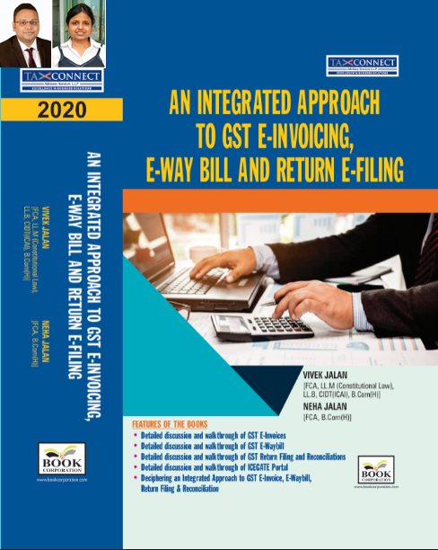

**ABOUT THE BOOK: This publication includes:**

1. **Detailed discussion and walkthrough of GST E-Invoices.**
2. **Detailed discussion and walkthrough of GST E-Waybill.**
3. **Detailed discussion and walkthrough of GST Return Filing and Reconciliations.**
4. **Detailed discussion and walkthrough of ICEGATE Portal.**
5. **Deciphering an Integrated Approach to GST E-Invoice, E-Waybill, Return Filing & Reconciliation**

**Authors:**

**Vivek Jalan**

***[FCA, L.LM (Constitutional Law), L.LB, CIDT(ICAI), B.Com(H)]***

**Neha Jalan**

***[FCA, B.Com(H)]***

**Published by:                                                                                                                                    In Association With:**

**BOOK CORPORATION                                                                                                            TAX CONNECT ACADEMY**

4, R. N. Mukherjee Road                                                                                                                     1, Old Court House Corner

Kolkata 700001                                                                                                                                                    Kolkata 700001

Phones: (033) 64547999                                                                                                                         Phones: (033) 40016761

Cell : 9830010297, 9331018333                                                                                                Cell : 9874466163, 9830661254

Order by email:[bookcorporation@gmail.com](mailto:bookcorporation@gmail.com)                                                                         Order by email: [info@taxconnect.co.in](mailto:info@taxconnect.co.in) Website :[www.bookcorporation.com](http://www.bookcorporation.com/)                                                                        Website : [www.taxconnect.co.in](http://www.taxconnect.co.in/)

**IN STANDS**

**Section wise Compendium on GST**

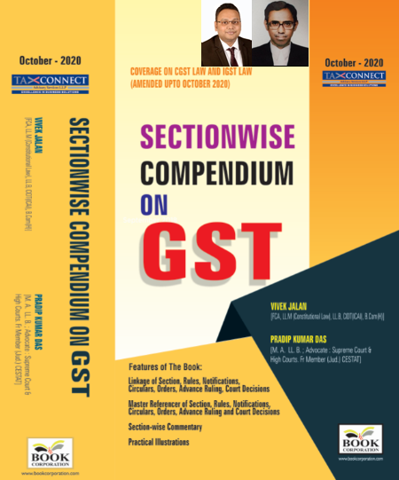

**ABOUT THE BOOK: This publication includes:**

**1. Linkage of Section, Rules, Notifications, Circulars, Orders, Advance Ruling, Court Decisions**

**2. Master Referencer of Section, Rules, Notifications, Circulars, Orders, Advance Ruling and Court Decisions**

**3. Section-wise Commentary**

**4. Practical Illustrations**

**Authors:**

**Vivek Jalan**

***[FCA, L.LM (Constitutional Law), L.LB, CIDT(ICAI), B.Com(H)]***

**Pradip Kumar Das**

***[M.A. LL.B; Advocate Supreme Court & High Courts; Fr. Mem (Jud.) CESTAT]***

**Published by:                                                                                                                                     In Association With:**

**BOOK CORPORATION                                                                                                            TAX CONNECT ACADEMY**

4, R. N. Mukherjee Road                                                                                                                     1, Old Court House Corner

Kolkata 700001                                                                                                                                                    Kolkata 700001

Phones: (033) 64547999                                                                                                                         Phones: (033) 40016761

Cell : 9830010297, 9331018333                                                                                                Cell : 9874466163, 9830661254

Order by email:[bookcorporation@gmail.com](mailto:bookcorporation@gmail.com)                                                                         Order by email: [info@taxconnect.co.in](mailto:info@taxconnect.co.in) Website :[www.bookcorporation.com](http://www.bookcorporation.com/)                                                                            Website : [www.taxconnect.co.in](http://www.taxconnect.co.in/)

**IN STANDS**

**UNION BUDGET 2021**

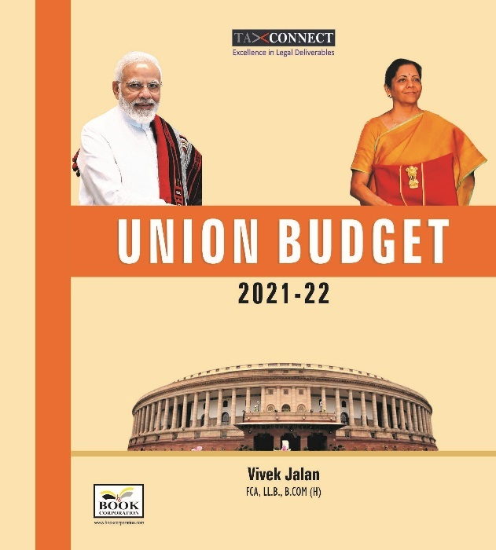

**ABOUT THE BOOK: This publication includes:**

**1.Commentary on Budget**

**2.Finance Minister’s Budget Speech**

**3.Budget at a Glance**

**4.Memorandum**

**a. Direct Tax**

**b. Customs**

**c. Excise**

**d. GST**

**5. Finance Bill**

**6. Notes on Clauses**

**Authors:**

**Vivek Jalan**

***[FCA, L.LM (Constitutional Law), L.LB, CIDT(ICAI), B.Com(H)]***

**Published by:                                                                                                                                     In Association With:**

**BOOK CORPORATION                                                                                                            TAX CONNECT ACADEMY**

4, R. N. Mukherjee Road                                                                                                                     1, Old Court House Corner

Kolkata 700001                                                                                                                                                    Kolkata 700001

Phones: (033) 64547999                                                                                                                         Phones: (033) 40016761

Cell : 9830010297, 9331018333                                                                                                Cell : 9874466163, 9830661254

Order by email:[bookcorporation@gmail.com](mailto:bookcorporation@gmail.com)                                                                         Order by email: [info@taxconnect.co.in](mailto:info@taxconnect.co.in) Website :[www.bookcorporation.com](http://www.bookcorporation.com/)                                                                            Website : [www.taxconnect.co.in](http://www.taxconnect.co.in/)

**LET’S DISCUSS FURTHER!**

**OUR OFFICES:**



**DUBAI**

Azizi Feirouz, 803, 8th Floor, AL Furjan, Opposite Discovery Pavillion, Dubai, UAE

Contact Person: Rohit Sharma

Email: rohit.sharma@taxconnect.co.in



**KOLKATA**

R No 119; 1st Floor; Diamond Arcade; 1/72, Cal Jessore Road; Kolkata – 700055

Contact Person: Priyanka Chowdhury

Email: priyanka.chowdhury@taxconnect.co.in



**KOLKATA**

1, Old Court House Corner, “Tobacco House”, 1st Floor, Room No. 13 (N), Kolkata-700001

Contact Person: Priyanka Chowdhury

Email: priyanka.chowdhury@taxconnect.co.in



**MUMBAI**

Building No.9, Flat- 403, LodhaEternis, 11th Road, MIDC, Andheri(E)-400093

Contact Person: Rajanikant Choudhury

Email: rajnikant.choudhary@taxconnectdelhi.co.in



**DELHI**

B-139, 2nd Floor, Transport Nagar, Noida-201301 (U.P)

Contact Person: Poonam Khemka

Email: poonam.khemka@taxconnectdelhi.co.in



**BANGALORE**

A-414,Carlton Towers, 19th Main; Road Hal Old Airport Rd, Domlur, Bengaluru, Karnataka-560008

Contact Person: Manmit Sinha

Email: manmit.sinha@taxconnectdelhi.co.in

**Disclaimer:**

*This e-bulletin is for private circulation only. Views expressed herein are of the editorial team and are based on the information, explanation and documents available on Government portal platforms. Tax Connect or any of its employees do not accept any liability whatsoever direct or indirect that may arise from the use of the information contained herein. No matter contained herein may be reproduced without prior consent of Tax Connect. While this e-article has been prepared on the basis of published/other publicly available information considered reliable, we do not accept any liability for the accuracy of its contents.*

Tax Connect 2021. All rights reserved.